Easily find « Commission en Direct » and Small Ads on « Teams After EC »
Since mid-2024, certain access were restricted for pensioners via MyRemote (https://myremote.ec.europa.eu + option « My IntraComm – Retired ») including, for example, the “Commission in Direct” articles summarised and delayed in time. As from 12/9/2025, MyIntraComm will disappear.
However, via the social network dedicated to former employees of the European Institutions called « Teams After EC », without EU Login, you may :
- via a PC or laptop : on the General channel at the top and then on the right,
click on the + after « Posts Files » … to open the option News for “Commission en Direct” or the option “Small Ads”.
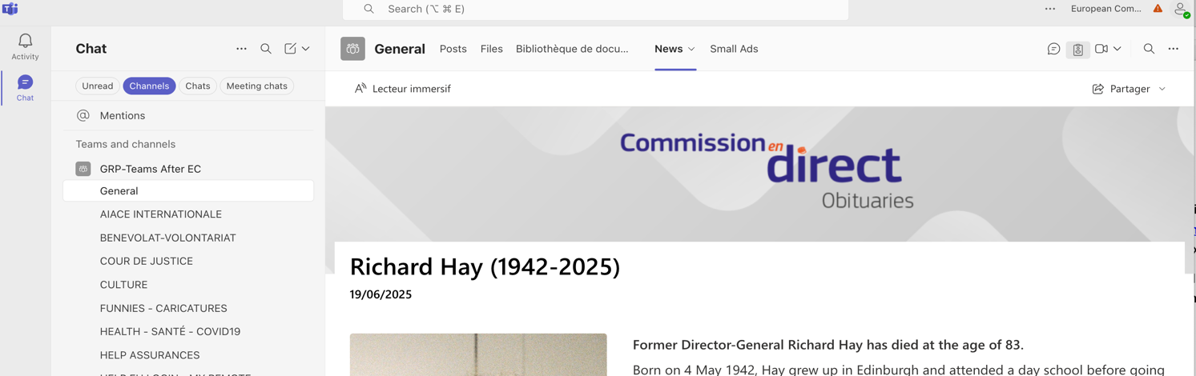
- Via a smartphone : click on Applications or Apps at the top, always in the General Channel | 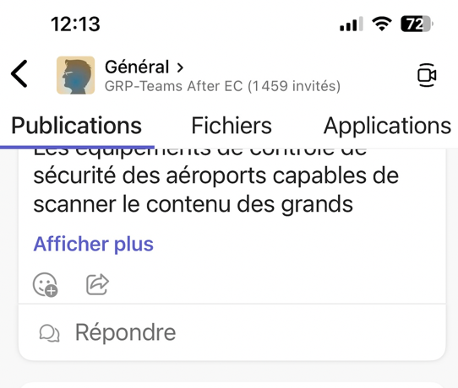
Teams After EC only requires a password that never changes and allows you to stay connected all day long ! No EU LOGIN required !
More info on Teams After EC : https://aiace-europa.eu/tools/teams-after-ec/
Intérested ? Send your contact details (surname, first name, pensioner number) to HR-TEAMS-AFTER-EC@ec.europa.eu You will receive practical information on how to log in.
Please note that “Small Ads” have been modernized.

