SYSPER Post Activity - Life Declaration & Life Certificate

As a pensioner of the European institutions (except for pensioners of the European Economic and Social Committee, the European Court of Justice and the European Parliament) we are required to send a Life declaration (sometimes bi-annual) together with a Life certificate at the request of the Pensions/PMO2 unit of the European Commission. This certificate has to be duly completed and signed by an authority for yourself and - as the case may be - for dependents or spouse. The Life declaration is a list of your personal data held by the European Commission. When returning the life certificate, you are supposed to check and if necessary, correct these data at the same time. PMO informs that there will be no automatic suspension of pension payments, even if there is a delay.
To avoid an excessive administrative burden, the PMO uses ‘life indicators’ that will remove this obligation, for example, for a pensioner who has submitted medical expenses or applied for prior authorization or direct billing from the JSIS.
YOU MUST THEREFORE WAIT UNTIL YOU RECEIVE A REQUEST FROM THE PMO AND SHOULD NOT SUBMIT A LIFE CERTIFICATE ON YOUR OWN INITIATIVE.
- RECEIVING THE FORMS TO BE FILLED AND SIGNED

Pensioners who have little or no use of computers will continue to get the forms by post.
Pensioners who have an EU Login account will get an email informing them that the form and the certificate are available in SYSPER Post Activity.

MyRemote via https://myremote.ec.europa.eu

Choose SYSPER Post Activity

Normally, as soon as you enter SYSPER you can click on “Open My Life Declaration”.

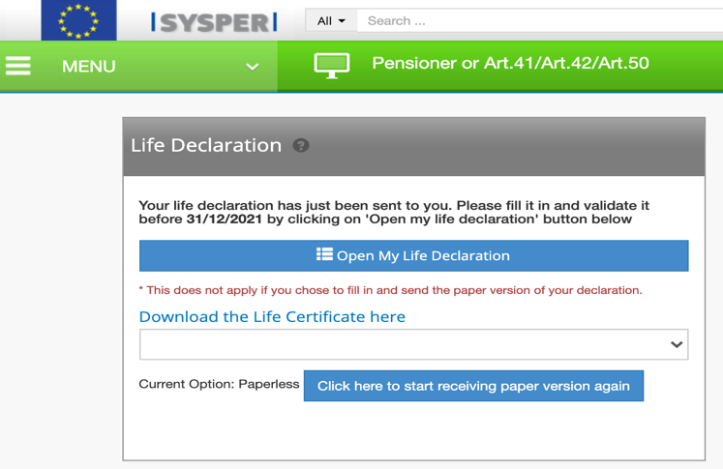

⚠ If this shortcut does not appear when you enter SYSPER, please go to item 3
- SENDING THE FORMS TO PMO ONCE SIGNED

A. Pensioners who have little or no knowledge of the use of computers can send the form and the certificate(s) to PMO by post.

However, for reasons of security and in order to facilitate the processing of the document, it is important to ask the competent authority to fill in the official certificate form sent by the Commission with the QR code (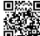) rather than a blank or similar form.

B. Pensioners who have an EU Login account can scan – and ideally clearly rename (Life certificate + name) - the duly completed and signed life certificate online. First connect to My Remote: https://myremote.ec.europa.eu and then go to the SYSPER Post Activity application. If the certificate was obtained online, a message with a shortcut will appear “Open My Life Declaration” as soon as you enter SYSPER.

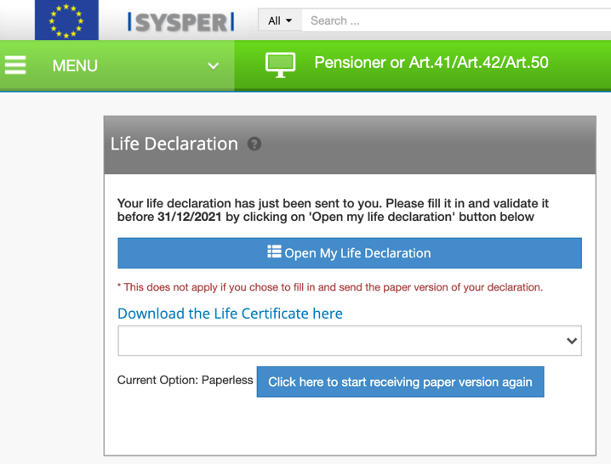

⚠ If this shortcut does not appear when you enter SYSPER, please go to item 3

The following screen will appear :

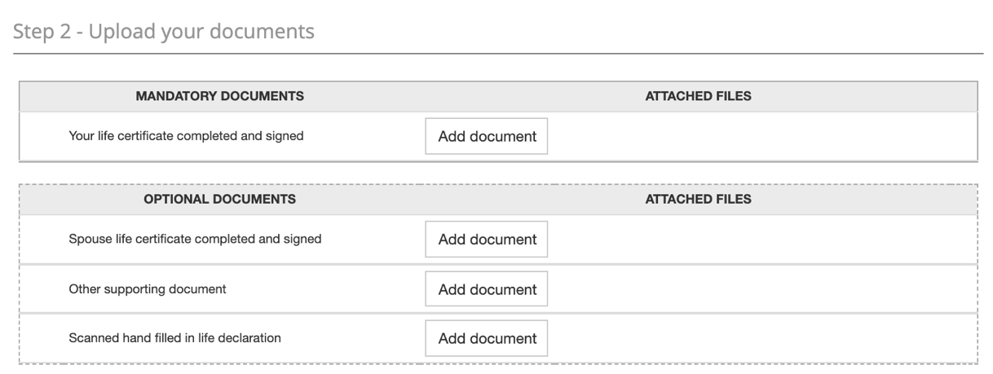

Click on “Add a document” and upload the scanned certificate, which will then appear under “Supporting documents”. Repeat the same procedure for a dependent.
Here is an example filled in for the pensioner:

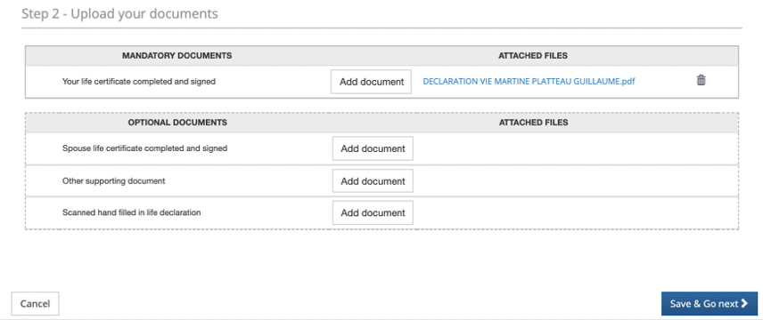

BEWARE:

If you selected the wrong document, just click on the waste bin on the righthand side.

Do not forget – as the case may be – to add the certificates for a spouse or dependent before you go to the next step.

If you received an official document without the Pensions Unit’s QR code, you can send it online via SYSPER Post Activity, but normally not by post.

If you have completed the Life Declaration by hand, you can scan it and add it to the OPTIONAL DOCUMENTS along with any other supporting documents to illustrate a change in family composition, for example.

If everything is correct, click on “Save & Go next”

A confirmation message will then appear: click on CONFIRM

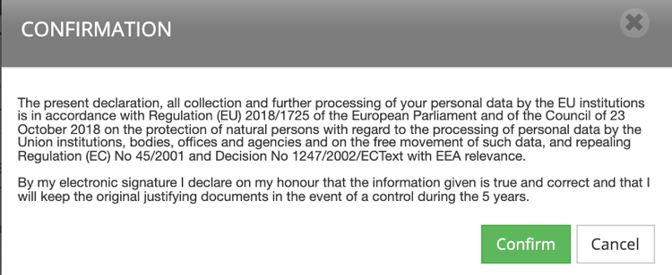

A new screen will then appear SUMMARY – My personal data; the content reflects the Declaration (biannual or not).

It is then also important to check/complete/correct all other information (personal details, details for a possible spouse or contact person) before clicking on  at bottom right. If you encounter difficulties to save what you have added or corrected, try to add a comment, it may help.

- HOW TO REACH THE “LIFE DECLARATION” SCREEN

If the “Life Declaration” shortcut does not appear when entering SYSPER Post Activity

In the My Remote application + SYSPER Post Activity:

Click on the 3 horizontal bars (also called “burger”) at the op left of the screen (next to MENU)

Scroll down and click on Rights & Privileges

Click on « Life declarations »

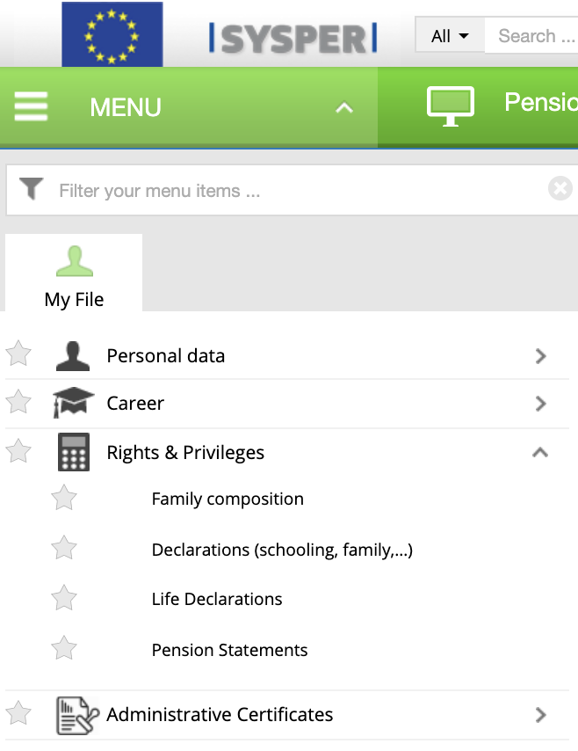

Scroll down in the page until you reach “Pensions” and “Life declarations”

Click on the arrow “open life declaration” on the far right

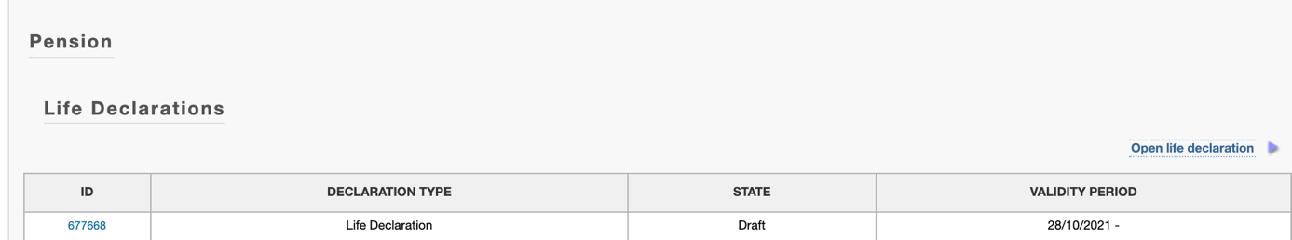

You will then be able to choose the language of the country you wish to use (and not necessarily your country of official residence).

Municipal registry office, notary, doctor, consul, lawyer, judge, or any equivalent authority

